***EXPERIMENT NO.6 2D ARRAY***

Program of 1D array:-

import java.util.Scanner;

public class array

{

public static void main(String args[])

{

int n;

Scanner sc=new Scanner(System.in);

System.out.println("Enter the number of the element you want to store: ");

n=sc.nextInt();

int[] array = new int[10];

System.out.println("Enter the element of the array:");

for(int i=0;i<n;i++)

{

array[i]=sc.nextInt();

}

System.out.println("Array element are:" );

for(int i=0;i<n;i++)

{

System.out.println(array[i]);

}

}

}

OUTPUT:-

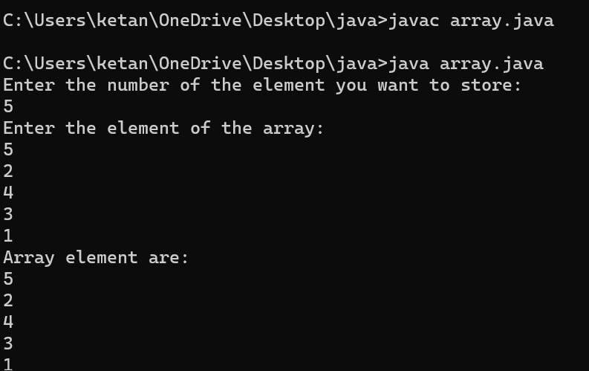

***Program of 2D array:-***

import java.util.Scanner;

public class Matrix

{

public static void main(String args[])

{

System.out.println("Enter the number of rows in matrix");

Scanner sc= new Scanner(System.in);

int row= sc.nextInt();

System.out.println("Enter the columns in the matrix");

int column = sc.nextInt();

int[][] first = new int[row][column];

int[][] second = new int[row][column];

for(int r=0; r<row;r++)

{

for(int c=0;c<column;c++)

{

System.out.println(String.format("Enter first [%d][%d] integer",r,c));

first[r][c]=sc.nextInt();

}

}

for (int r = 0; r < row; r++)

{

for (int c = 0; c < column; c++)

{

System.out.println(String.format("Enter second[%d][%d] integer", r, c));

second[r][c] = sc.nextInt();

}

}

System.out.println("First Matrix:\n");

print2dArray(first);

System.out.println("Second Matrix:\n");

print2dArray(second);

System.out.println("Main Menu");

System.out.println("1.Additionof matrix");

System.out.println("2.Substraction of matrix");

System.out.println("3.Multiplication of matrix");

System.out.println("4.Exit");

System.out.println("Enter your option");

int option=sc.nextInt();

sc.close();

switch(option)

{

case 1:

sum(first, second);

break ;

case 2:

substraction(first,second);

break;

case 3:

multiplication(first,second);

break;

}

}

private static void sum(int[][]first ,int[][]second)

{

int row =first.length;

int column=first[0].length;

int[][] sum= new int[row][column];

for(int r=0;r<row;r++)

{

for(int c=0;c<column;c++)

{

sum[r][c] = first[r][c] + second[r][c];

}

}

System.out.println("Sum of matrix");

print2dArray(sum);

}

static void substraction(int[][]first ,int[][]second)

{

int row =first.length;

int column=first[0].length;

int[][] sum= new int[row][column];

for(int r=0;r<row;r++)

{

for(int c=0;c<column;c++)

{

sum[r][c]=first[r][c]-second[r][c];

}

}

System.out.println("Substraction of matrix");

print2dArray(sum);

}

static void multiplication(int[][] first, int[][] second)

{

int row = first.length;

int column = first[0].length;

int[][] sum = new int[row][column];

for (int r = 0; r < row; r++) {

for (int c = 0; c < column; c++) {

sum[r][c] = first[r][c] * second[r][c];

}

}

System.out.println("\nMultiplication of Matrices:\n");

print2dArray(sum);

}

static void print2dArray(int[][] matrix)

{

for(int r=0;r<matrix.length;r++)

{

for(int c=0;c<matrix[0].length;c++)

{

System.out.print(matrix[r][c] + "\t");

}

System.out.println();

}

}

}

